1. Go to <https://colab.research.google.com/notebooks/welcome.ipynb>
2. Log in with any of your google account.
3. On the left top corner, click File, and open a new python2 notebook.

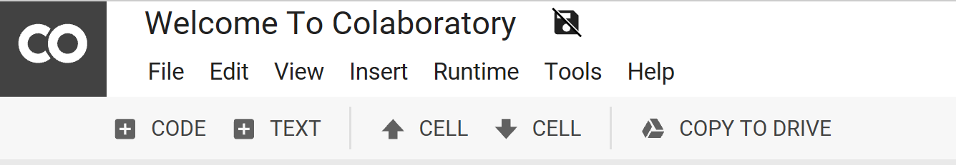

1. After creating a new notebook, copy the baseline code into the following window and click on the “play” button to run the code:

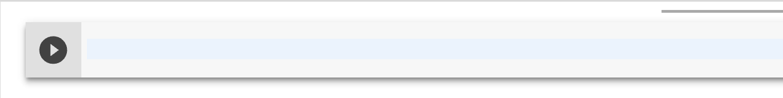

The output should somehow similar to the screenshot below: (due to the internet connection and server computing capability, you might need to wait for a while to get the results, please be patient.)

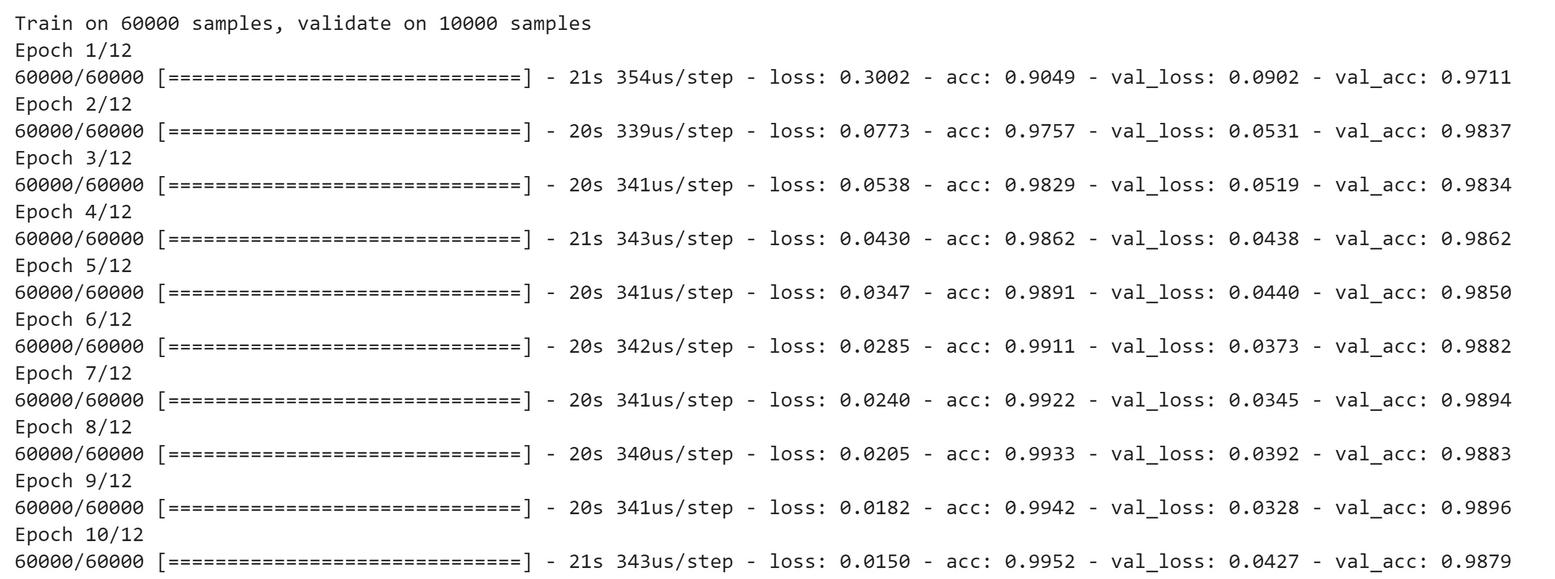

After verifying the baseline, you can change

1. Batch_size,

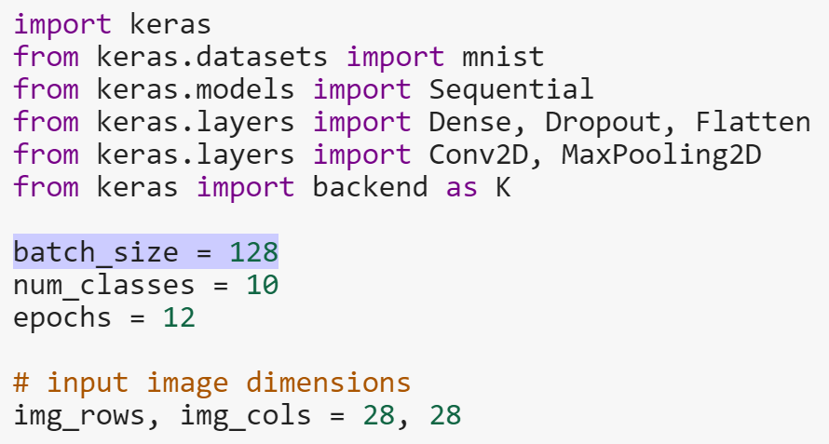

1. Featuremap size

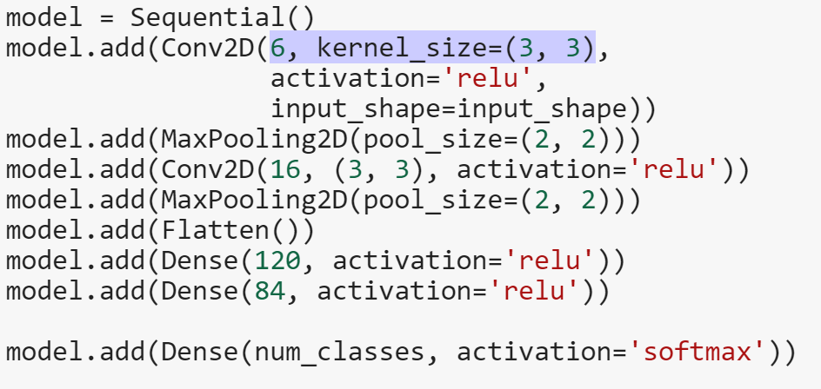

1. Learning rate

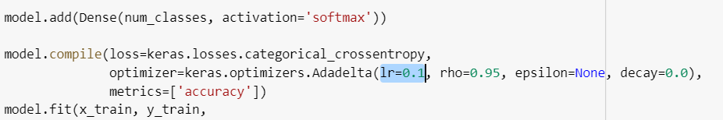

1. different optimizer. For details about the optimizer, you can check it here. <https://keras.io/optimizers/>

